EI protocol

1. File-> New protocol
(Default anatomy->No, use individual anatomy)
(Default channel file-> no, use one channel file per acquisition run)
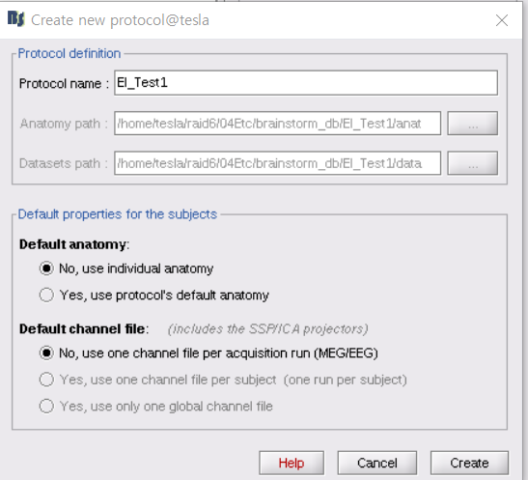

2. New subject
(Default anatomy->No, use individual anatomy)
(Default channel file-> no, use one channel file per acquisition run)
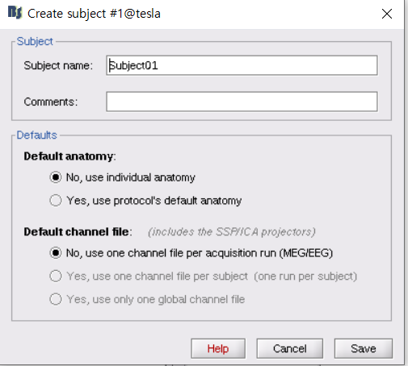

3. Pre-implantation MRI
subject-> import MRI
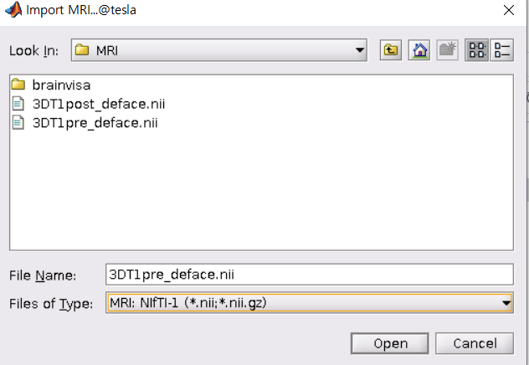

yes
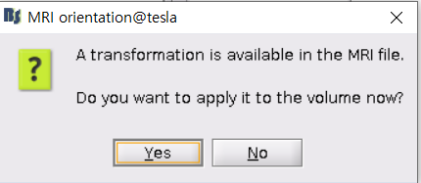

Click here to compute MNI normalization
maff8
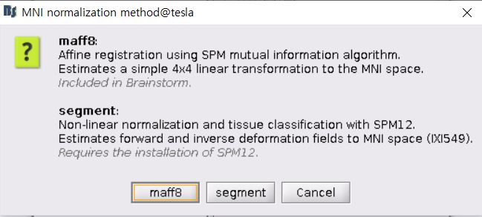

4. post-implantation MRI
subject-> import MRI (DICOM or nii)
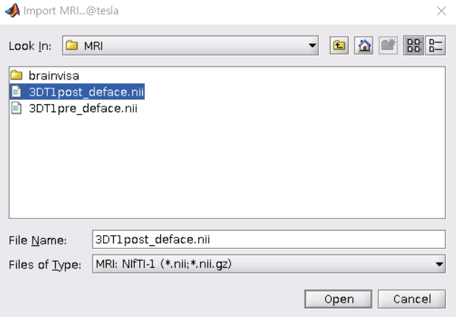

Yes
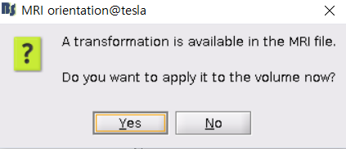

ignore
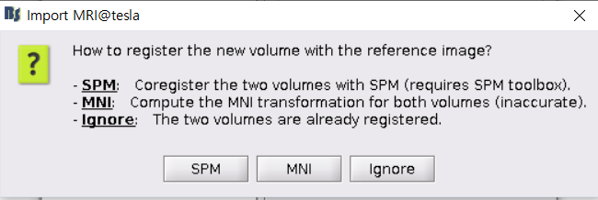

Yes
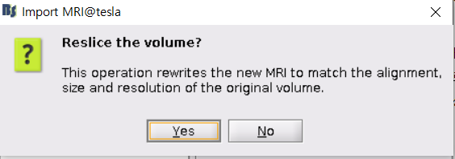

5. Generate SPM canonical surfaces
Run->import->import anatomy->Generate SPM canonical surfaces-> run
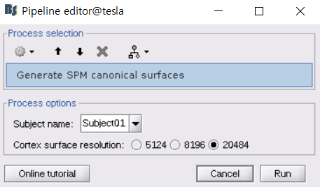

Check the results
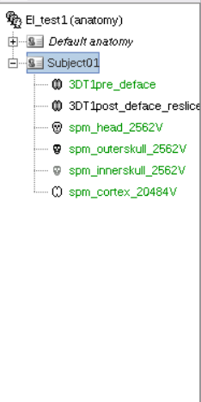

6. Link the recordings
Right-click on the subject folder > Review raw file
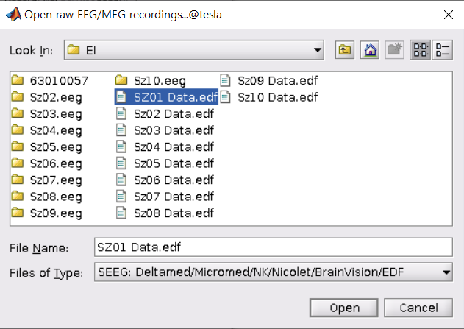

7. Import sEEG locations
Right-click on the subject folder > add eeg positions-> import from file
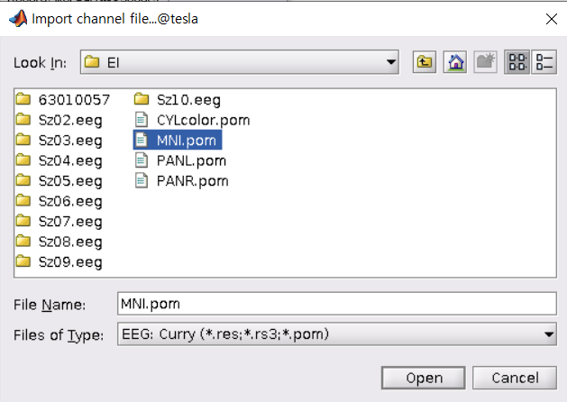

yes
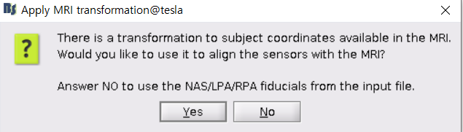

8. Event marking
Event->add group (onset, baseline)
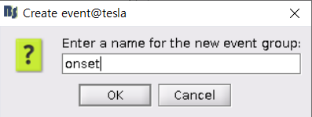

Right-click on the data-> Add event
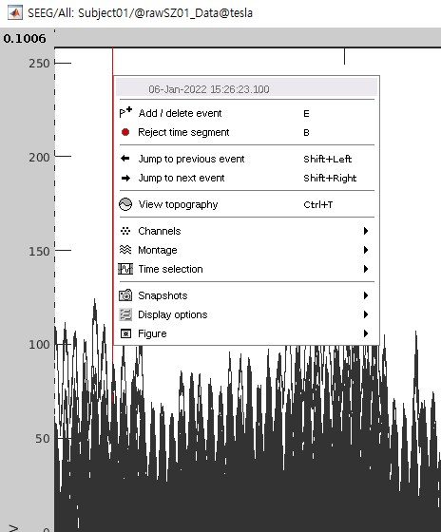

9. export from the data (onset, baseline)
Right-click on the subject folder > import in database
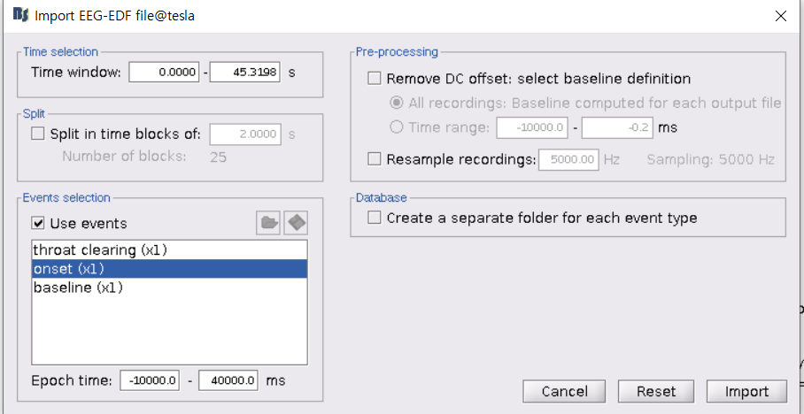

Right-click on the subject folder > import in database
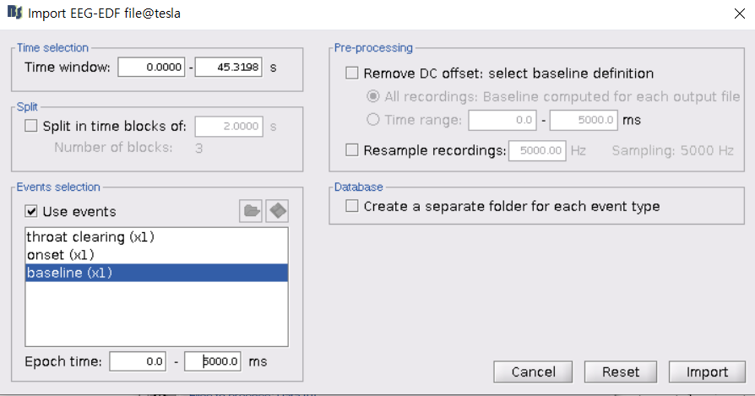

10. elipeptogenecity maps
Process2-> files A: baseline, file B: onset
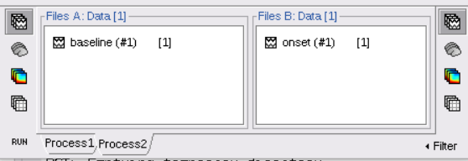

Run-> epilepsy-> elipeptogenecity maps
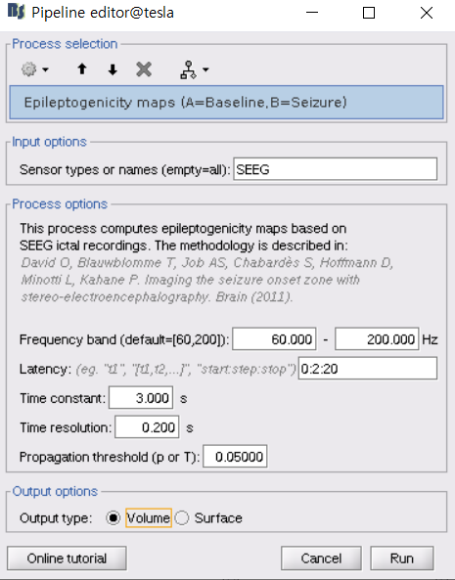

Result
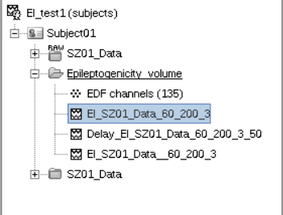

When using tutorial data (in Same protocol, only difference is sEEG and location files)
